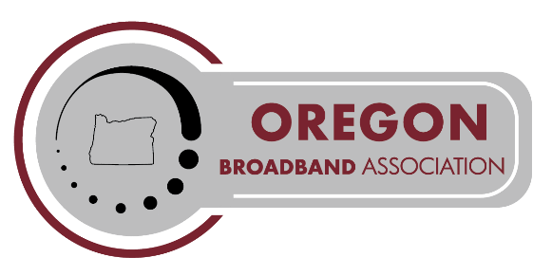2025 Outside Plant Seminar  
May 15 & 16

**Best Western Plus – Hood River Inn**

**REGISTRATION INFORMATION**

**Cut-off Date: Please submit your seminar registration no later than** **Friday, April 28, 2025 by 5:00 p.m.**

Register **Online** at[www.ota-telecom.org/events](http://www.ota-telecom.org/events)

|  |  |
| --- | --- |
| Member Registration received by Cut-off Date: (includes employees of other State Associations) | $350.00 |
| Member Exhibit fee per table: ***(in addition to at least one registration fee)*** | $125.00 |
| Late Registration received after Friday, April 28, 2025 | $50.00 |
| Meal Pass/Guest Meals: For companies with more than 2 reps** **or** for guest of registered attendee | $200.00 |
| Refreshment Break Sponsorship (coffee, tea, bottled water, soft drinks, food items) | $500.00 |
| Meal Sponsorship (coffee, tea, bottled water, soft drinks, buffet meal) (3 available) | $1,000.00 |
| Partial Sponsorship of Evening Reception (2 available) | $750.00 |
| Sponsorship – General | $You Pick |
| Non-Member Fees – added to both registration & exhibit fees | $125.00 |

**HOTEL LODGING INFORMATION**

**For hotel reservations, call 800-828-7873.** Please indicate that you are with the **OBA Outside Plant Seminar group**. **Or use our group link for web reservations found on our website.** **The cut-off date for making lodging reservations in our room block is April 15.** Please make your room reservations as soon as possible to ensure access to our limited group rates.

|  |  |
| --- | --- |
| **Room Type** | **Rate Per Night** |
| River View (single or double occupancy) – Multiple Types | $ 159-189* |
| *\*All room rates are based on single or double occupancy and quoted exclusive of applicable local tax. Each additional adult will be charged $15.00 per room per night.* | |

**GENERAL SCHEDULE.** Plan for arrival the evening before our event! We kick off early each day with breakfast from 7-8 a.m. Day 1 is packed with educational sessions and networking opportunities, including a welcome reception. Day 2 runs a half day.

**SPONSORSHIP OPPORTUNITIES.** Are you interested in helping us keep our costs down for attendees or an additional opportunity to showcase your company? Sponsors will be acknowledged in the printed seminar program, announced from the podium, with on-site signage and in the following issue of OBA’s quarterly eNewsletter. Thank you for your generous support! We appreciate your support and couldn’t do this with-out our amazing sponsors!

**EXHIBITOR INFORMATION\*\*** Six-foot skirted tables and power are included in the exhibit fee. The first two representatives from an exhibiting company must pay the full registration fee. The third representative and up pay only for the cost of a guest meal pass. If you will be shipping display materials or equipment to the site, please ship to arrive no earlier than one day prior to the event and arrange for items to be shipped out within one day after the event. Ship to: Best Western Plus – 1108 East Marina Way – Hood River, OR 97031 Attention: OBA OSP Seminar (May 15/16)

**PAYMENT OPTIONS**. Pay with a credit card directly from our Intuit QB invoice emailed to you or mail a check after receiving an invoice. Please note card payments will also include a 3% processing fee. Do note that we process registrations manually, so an invoice is not automatically generated at submission. We appreciate your patience as we work through registrations in the order received.

**PLEASE NOTE.** Hotel and catering policies require guaranteed number of attendees and headcounts two weeks prior to our events. We appreciate your understanding of this. Therefore, **cancellations made after Wednesday, April 30 and “no-shows” will be charged the full registration fee and are not refundable.**

*If you require special arrangements in order to fully participate in our event,*

*please email us so we can discuss how to meet your needs at mjundt@oba-telecom.org.*